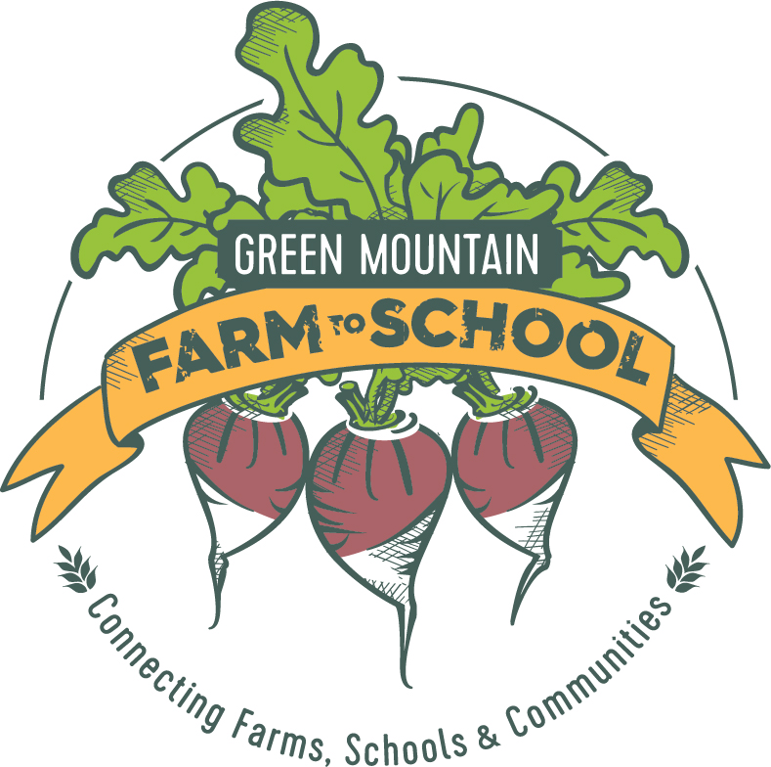

Consumer Education and Food Access Coordinator
Location: Newport, Vermont

About Green Mountain Farm-to-School
Green Mountain Farm-to-School (GMFTS) is a nonprofit organization promoting the health and wellbeing of Vermont's children, farms, and communities by connecting schools and farms through food and education. We do this by building school gardens, delivering local food to schools and institutions, and educating the community about healthy food choices. For more information about GMFTS, please visit www.greenmountainfarmtoschool.org.

Position Description
Green Mountain Farm-to-School seeks a dynamic, mission-driven local-food systems professional with strong project management and customer service skills to manage our community focused programs and increase access to healthy local foods in the community. The Consumer Education and Food Access Coordinator reports to the Program Director of Green Mountain Farm-to-School.

The Consumer Education and Food Access Coordinator will:
- Serve as customer service representative for Green Mountain Farm Direct, GMFTS’ food hub, by building and maintaining relationships with customers, including schools, grocers, other institutions
- Coordinate food nutrition incentive programs in collaboration with major partners and stakeholders
- Coordinate the Lunchbox Food Truck, GMFTS’ 10-week summer meal program
- Coordinate Vermont Harvest of the Month, a web-based marketing campaign to promote seasonal local food
- Coordinate monthly local food tastings at independent grocery stores
- Develop compelling brochures, flyers, and fact sheets about our programs and accessing local food
- Develop and implement evaluation tools; collect, analyze, and report data for program evaluation
- Organize, attend and present at business, community, and neighborhood group meetings
- Supervise seasonal intern for summer meal program
- Plan and organize annual series of on-farm community dinners
- Implement promotional and marketing plans
- Conduct community outreach and marketing efforts to raise awareness about the importance of eating healthy and available resources, services, and supports related to healthy food.
- Act as the back-up for Green Mountain Farm Direct Coordinator during vacations and holidays, as needed
- Provide general support to Green Mountain Farm-to-School, as necessary

Qualifications
- A Bachelors degree
- Experience in outreach or community engagement; demonstrated ability to establish effective and productive working relationships with diverse groups
- Experience in customer service, sales and marketing
- Knowledge of local food systems and sustainable agriculture
- Excellent verbal and written communication skills with exceptional attention to detail
- Strong, public speaking, and interpersonal skills
- Experience working in a low-income, community-based setting a plus
- Good computer skills including Microsoft Office
- Self-directed and can take initiative
- Ability to prioritize and manage workload in a fast-paced, rapidly growing non-profit environment
- Valid driver’s license

Compensation
This is a full-time position (40 hours/week, Monday – Friday with occasional weekends) with salary range $32,000-$35,000 and benefits commensurate with experience.

To Apply: Submit a cover letter, resume, and three references to jobs@gmfts.org. No phone calls please. GMFTS is committed to creating a diverse environment and is proud to be an equal opportunity employer. All qualified applicants are encouraged to apply. Deadline to apply is November 16, 2017.

